**main.html**

<!DOCTYPE html>

<head>

    <meta charset="UTF-8">

    <meta name="viewport" content="width=device-width, initial-scale=1.0">

    <title>Hotel Website</title>

    <link rel="stylesheet" href="styles.css">

</head>

<body>

    <div class="container">

        <h1>Welcome to Our Hotel !</h1>

        <div class="buttons">

            <a href="login.html" class="btn">Login</a>

            <a href="signup.html" class="btn">Sign Up</a>

        </div>

    </div>

</body>

</html

**login.html**

<!DOCTYPE html>

<head>

    <meta charset="UTF-8">

    <meta name="viewport" content="width=device-width, initial-scale=1.0">

    <title>Login - Hotel Website</title>

    <link rel="stylesheet" href="styles.css">

</head>

<body>

    <div class="form-container">

        <h2>Login</h2>

        <form id="loginForm">

            <label for="username">Username</label>

            <input type="text" id="username" name="username" required>

            <label for="password">Password</label>

            <input type="password" id="password" name="password" required>

            <button type="submit">Login</button>

        </form>

    </div>

    <script>

        document.getElementById('loginForm').addEventListener('submit', function(event) {

            event.preventDefault();

            window.location.href = 'facilities.html';

        });

    </script>

</body>

**signup.html**

<!DOCTYPE html>

<head>

    <meta charset="UTF-8">

    <meta name="viewport" content="width=device-width, initial-scale=1.0">

    <title>Sign Up - Hotel Website</title>

    <link rel="stylesheet" href="styles.css">

</head>

<body>

    <div class="form-container">

        <h2>Sign Up</h2>

        <form id="signupForm">

            <label for="username">Username</label>

            <input type="text" id="username" name="username" required>

            <label for="email">Email</label>

            <input type="email" id="email" name="email" required>

            <label for="password">Password</label>

            <input type="password" id="password" name="password" required>

            <button type="submit">Sign Up</button>

        </form>

    </div>

    <script>

        document.getElementById('signupForm').addEventListener('submit', function(event) {

            event.preventDefault();

            window.location.href = 'login.html';

        });

    </script>

</body>

</html>

**Facilities.html**

<!DOCTYPE html>

<html lang="en">

<head>

    <meta charset="UTF-8">

    <meta name="viewport" content="width=device-width, initial-scale=1.0">

    <title>Facilities - Hotel Website</title>

    <link rel="stylesheet" href="styles.css">

</head>

<body>

    <div class="container">

        <h1>Facilities & Amenities</h1>

        <p>Explore the facilities and amenities available at our hotel:</p>

        <ul>

            <li>Swimming Pool: Enjoy our spacious pool with a view.</li>

            <li>Spa & Wellness Center: Relax with our spa treatments.</li>

            <li>Fitness Center: Stay fit with our modern gym equipment.</li>

            <li>Business Center: Convenient facilities for work needs.</li>

            <li>Restaurant & Bar: Delicious dining and drinks onsite.</li>

        </ul>

    </div>

</body>

</html>

**Styles.css**

body {

    font-family: Arial, sans-serif;

    background-color: #f4f4f4;

    margin: 0;

    padding: 0;

    background-image: url('background.jpg');

    background-size: cover;

    background-position: cover;

    background-repeat: no-repeat;

    margin: 5px auto;

    max-width: 600px;

}

.container {

    /* text-align: justify; */

    padding: 50px;

    /*background-color: rgba(255, 255, 255, 0.8); */

    border-radius: 10px;

    display: inline-block;

    margin-top: 10%;

    justify-content: right;

}

.buttons {

    margin-top: 20px;

}

.btn {

    text-decoration: none;

    background-color: #0c014b;

    color: rgb(243, 234, 234);

    padding: 10px 20px;

    border-radius: 5px;

    margin: 5px;

}

.btn:hover {

    background-color: #024a93;

}

.form-container {

    max-width: 400px;

    margin: 50px auto;

    padding: 20px;

    background-color: white;

    box-shadow: 0 0 10px rgba(0, 0, 0, 0.1);

}

form {

    display: flex;

    flex-direction: column;

}

label {

    margin-bottom: 5px;

}

input {

    margin-bottom: 15px;

    padding: 10px;

    border: 1px solid #ccc;

    border-radius: 5px;

}

button {

    padding: 10px;

    border: none;

    border-radius: 5px;

    background-color: #0c4480;

    color: white;

    cursor: pointer;

}

button:hover {

    background-color: #0056b3;

}

h1{

    color: white;

    /*text-align: justify;*/

}

**Output:**

Main page:

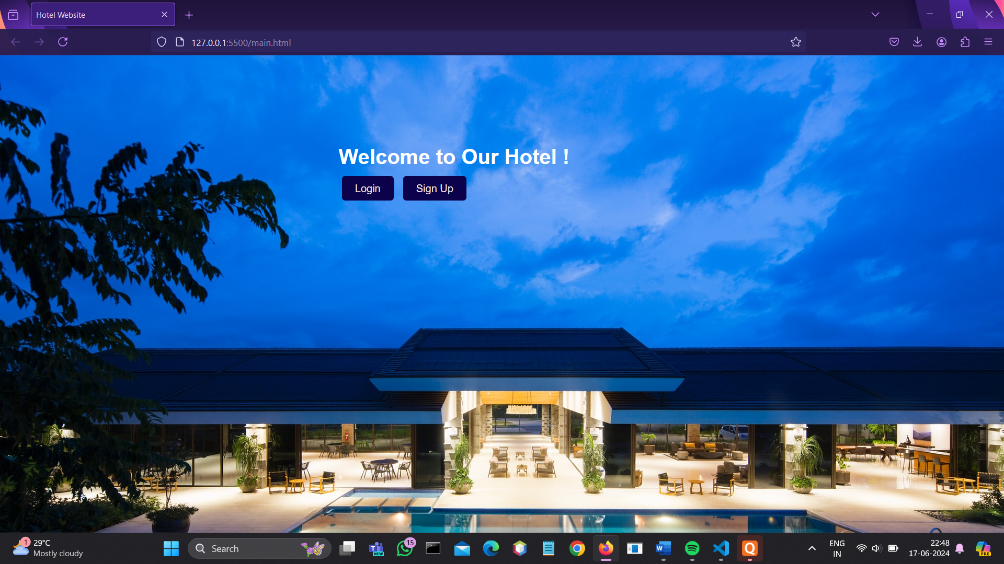

Login page:

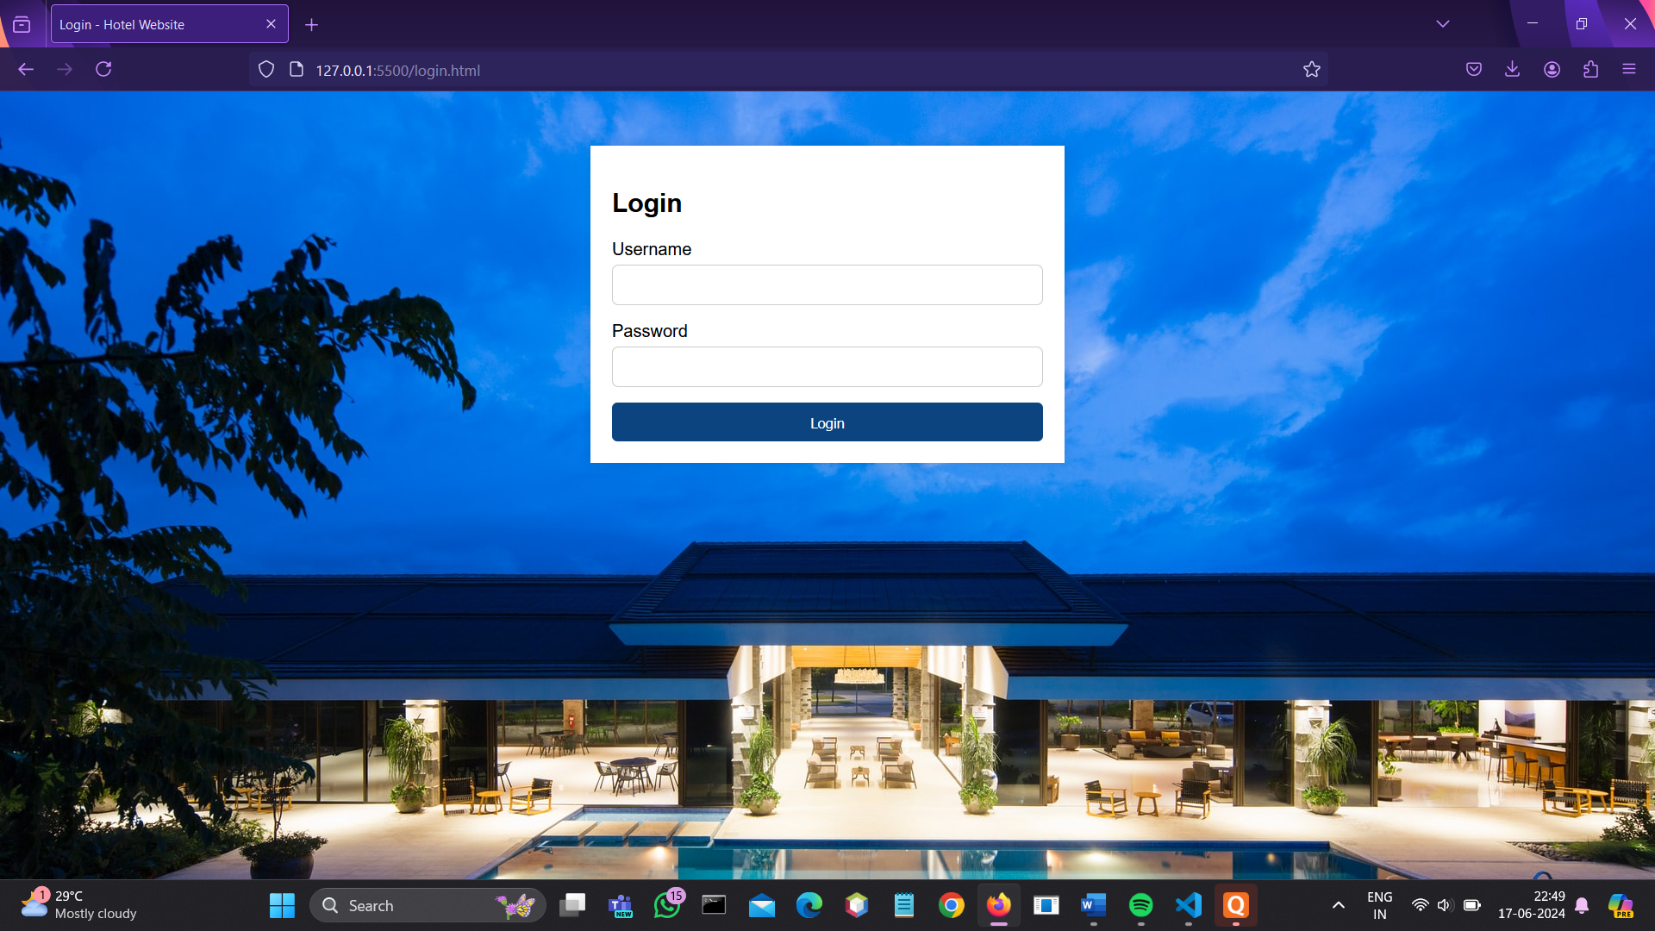

Signup page:

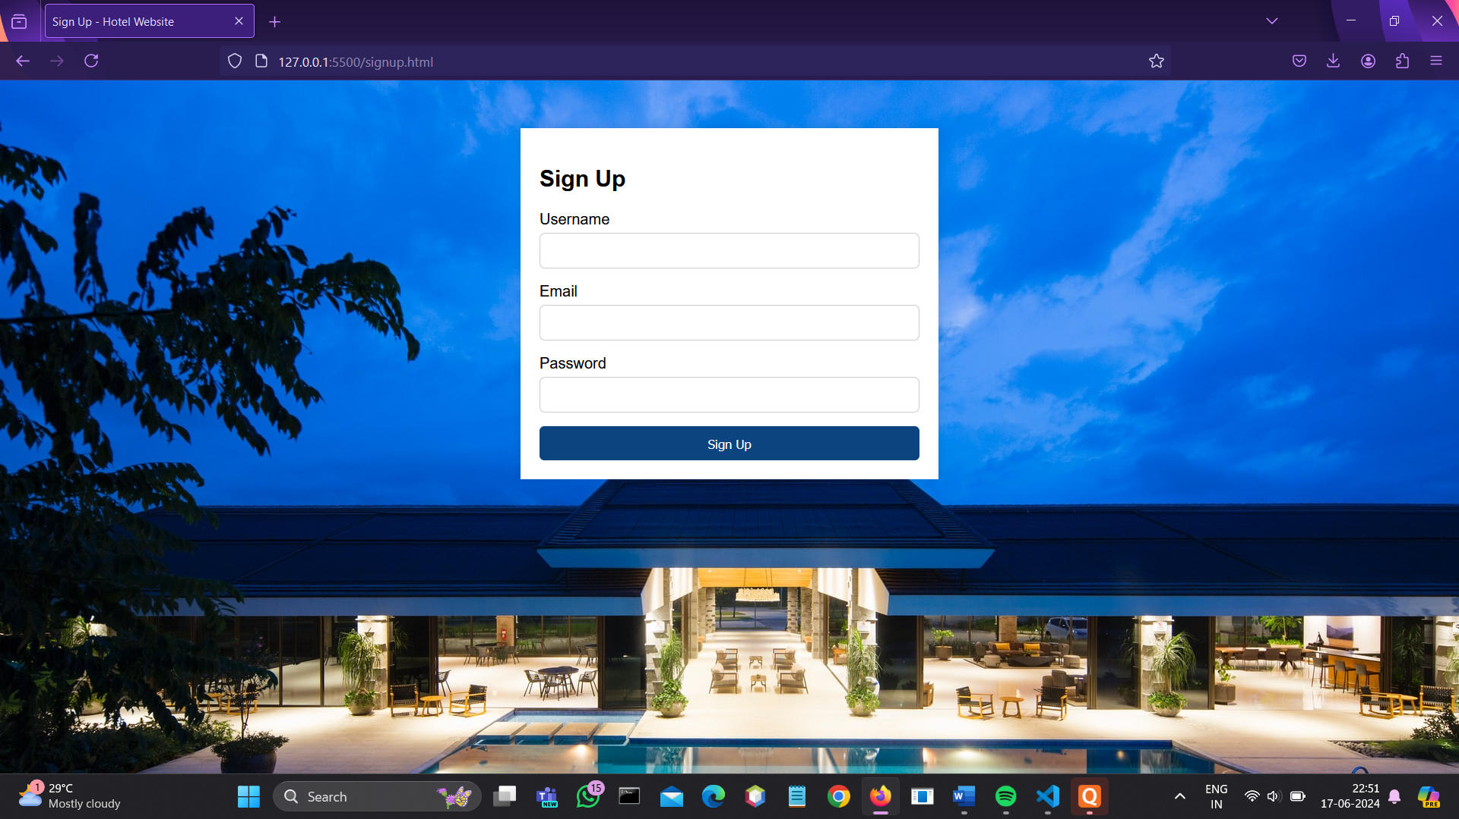

**Facilities & Amenities:**

